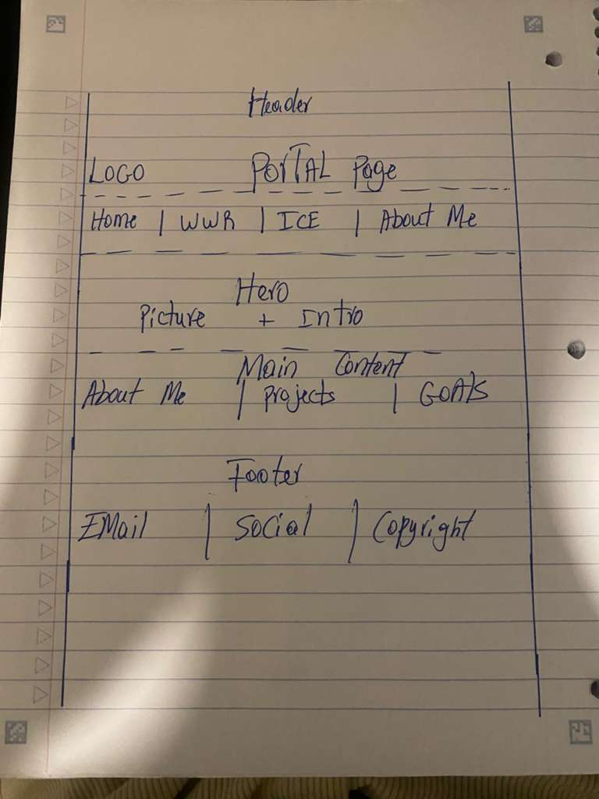
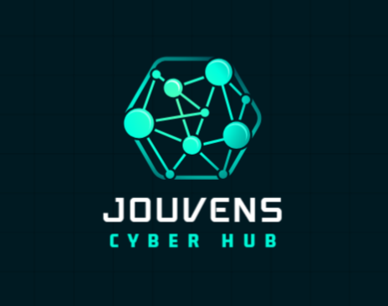
Portal Page Design Document

Website Name:
Jouvens Cyber Portal

Purpose:
This portal page will collect my WDD130 work and serve as a portfolio website where I can organize my projects, assignments, and web development progress.

Logo:
Jouvens Cyber Hub

Logo Theme:
Cybersecurity and Technology

Color Palette:
Primary: #396E94 (blue)
Secondary: #E7C24F (gold)
Accent 1: #A42212 (red)
Accent 2: #FFFFFF (white)
Background: #1B1B1B (dark)

Fonts:
Heading Font: Arial
Body Font: Lato

Navigation:
• Home
• WWR
• ICE
• About Me

Sections:
• Header
• Navigation
• Main
• Footer
• Hero Image
• About Me Content
• Links to Projects

Wireframe Description:
The portal page will have a header at the top with a logo and website title. Under the header will be a navigation menu with links to Home, WWR, ICE, and About Me. The main section will include a hero image, introduction content, projects, goals, and information about me. The footer will contain contact information, social links, and copyright information.

